<comment>
Functions to familiarize:
1. Linear SVC The objective of a Linear SVC (Support Vector Classifier) is to fit to the
data you provide, returning a "best fit" hyperplane that divides, or categorizes,
your data. From there, after getting the hyperplane, you can then feed some features
to your classifier to see what the "predicted" class is.

2. CountVectorizer:
Creates a matrix in which each unique word is represented by a column of the
matrix, and each text sample from the document is a row in the matrix. The value of
each cell is nothing but the count of the word in that particular text sample.
<comment>

Given a data set of support tickets. Each ticket also has an associated
"urgency score" of between 0 and 3, and where 0 is "very urgent" and 3
is "not urgent". It would be useful if we could have a machine guess
how urgent a ticket is, based on the description, so the urgent tickets
can be resolved first

1. For the given data set, perform text classification using SVM and
find out the accuracy of the model.

Code:

from sklearn.feature_extraction.text import TfidfVectorizer, CountVectorizer

from sklearn.metrics import confusion_matrix
from sklearn.metrics import classification_report

from sklearn.model_selection import cross_val_score
from sklearn.model_selection import cross_val_predict
from sklearn.model_selection import train_test_split

from sklearn.svm import LinearSVC
from sklearn.tree import DecisionTreeClassifier
from sklearn import tree

with open("tickets.txt") as f:
tickets = f.read().strip().split("\n")

with open("labels_4.txt") as f:
labels = f.read().strip().split("\n")

X_train, X_test, y_train, y_test = train_test_split(tickets, labels, test_size=0.1, random_state=1337)

vectorizer = CountVectorizer()
svm = LinearSVC()
X_train = vectorizer.fit_transform(X_train)
X_test = vectorizer.transform(X_test)
_ = svm.fit(X_train, y_train)
y_pred = svm.predict(X_test)
print(classification_report(y_test, y_pred))

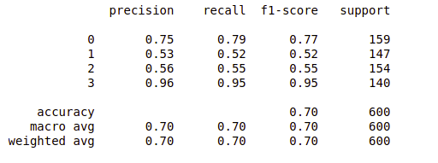
Reference:
- https://www.codementor.io/blog/text-classification-6mmol0q8oj

